Scan Report: Scanning & Enumeration
Course: NIAI NAVTTC — Certified Ethical Hacker (CEH) Course
Assignment: Week 3 Lab Task
Prepared By: Talha Ali
Important Notice: All tasks documented in this report were performed only in an isolated virtual lab environment. Never test on real networks or systems without explicit written permission.
1. Executive Summary
- Objective: Conduct a comprehensive network scan to identify all active hosts and services, and perform vulnerability scanning on identified hosts. Perform active enumeration to identify users, groups, and systems.
- Target Machine: Metasploitable 2
- Target IP Address: 192.168.1.5

2. Host Discovery (Ping Sweep)
Command used: nmap -sn 192.168.1.0/24
- Active Hosts Found: 5 total hosts up on the network.
  - 192.168.1.1 (Hostname: gpon.net) - MAC: QEMU virtual NIC
  - 192.168.1.2 - MAC: QEMU virtual NIC
  - 192.168.1.3 - MAC: Oracle VirtualBox virtual NIC
  - 192.168.1.4 (Kali Linux Host)
  - 192.168.1.5 (Metasploitable 2 Target) - MAC: Oracle VirtualBox virtual NIC
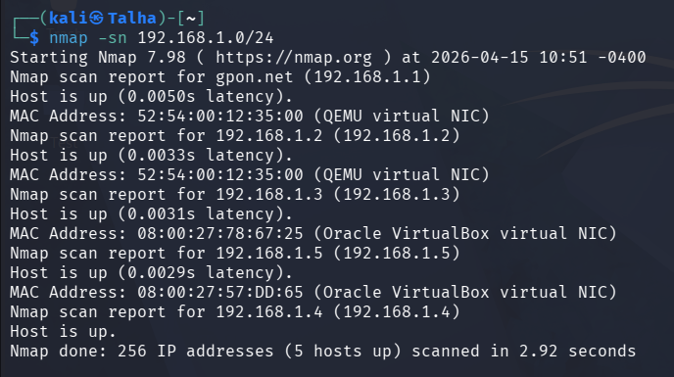

3. Port Scanning & Service Detection
Command used: nmap -sV -p- 192.168.1.5
- Open Ports & Services:
Port/Protocol | State | Service | Version
21/tcp | open | ftp | vsftpd 2.3.4
22/tcp | open | ssh | OpenSSH 4.7p1 Debian 8ubuntu1 (protocol 2.0)
23/tcp | open | telnet | Linux telnetd
25/tcp | open | smtp | Postfix smtpd
53/tcp | open | domain | ISC BIND 9.4.2
80/tcp | open | http | Apache httpd 2.2.8 ((Ubuntu) DAV/2)
111/tcp | open | rpcbind | 2 (RPC #100000)
139/tcp | open | netbios-ssn | Samba smbd 3.X - 4.X (workgroup: WORKGROUP)
445/tcp | open | netbios-ssn | Samba smbd 3.X - 4.X (workgroup: WORKGROUP)
512/tcp | open | exec?
513/tcp | open | login
514/tcp | open | tcpwrapped
1099/tcp | open | java-rmi | GNU Classpath grmiregistry
1524/tcp | open | bindshell | Metasploitable root shell
2049/tcp | open | nfs | 2-4 (RPC #100003)
2121/tcp | open | ftp | ProFTPD 1.3.1
3306/tcp | open | mysql | MySQL 5.0.51a-3ubuntu5
3632/tcp | open | distccd | distccd v1 ((GNU) 4.2.4 (Ubuntu 4.2.4-1ubuntu4))
5432/tcp | open | postgresql | PostgreSQL DB 8.3.0 - 8.3.7
5900/tcp | open | vnc | VNC (protocol 3.3)
6000/tcp | open | X11 | (access denied)
6667/tcp | open | irc | UnrealIRCd
6697/tcp | open | irc | UnrealIRCd
8180/tcp | open | unknown
8787/tcp | open | drb | Ruby DRb RMI (Ruby 1.8; path /usr/lib/ruby/1.8/drb)
36043/tcp | open | nlockmgr | 1-4 (RPC #100021)
53262/tcp | open | java-rmi | GNU Classpath grmiregistry
54124/tcp | open | mountd | 1-3 (RPC #100005)
58160/tcp | open | status | 1 (RPC #100024)
- Additional Service Info: Hosts: metasploitable.localdomain, irc.Metasploitable.LAN; OSs: Unix, Linux.
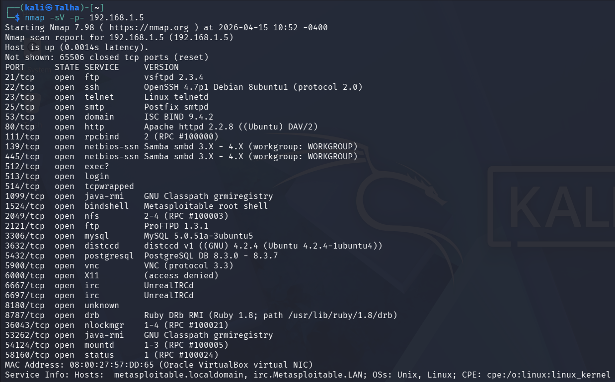4. Operating System Detection
Command used: nmap -O 192.168.1.5
- Operating System Detected: Linux 2.6.X
- OS Details: Linux kernel 2.6.9 - 2.6.33
- Device Type: General purpose
- Network Distance: 1 hop

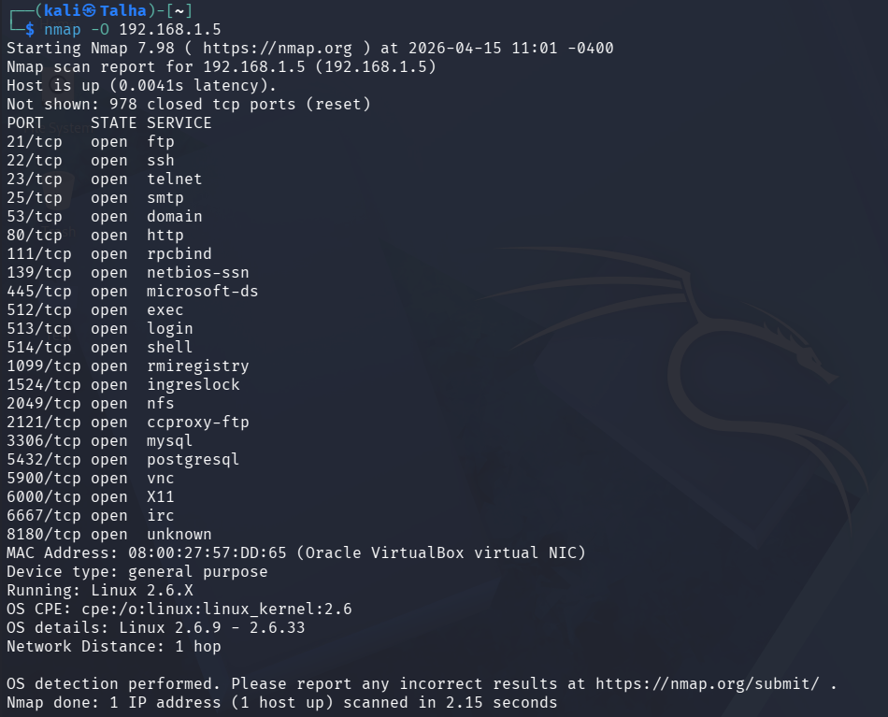
5. Vulnerability Scanning
Command used: nmap --script vuln 192.168.1.5
Vulnerabilities Flagged:
- Port 21 (FTP): vsFTPd version 2.3.4 backdoor (CVE-2011-2523). Highly critical: allows immediate root shell access.
- Port 25 (SMTP): SSL POODLE information leak (CVE-2014-3566), Anonymous Diffie-Hellman Key Exchange MitM Vulnerability, and TLS Protocol DHE_EXPORT Ciphers Downgrade MitM (Logjam - CVE-2015-4000).
- Port 80 (HTTP): Multiple potential SQL Injection vulnerabilities (e.g., within Mutillidae pages) and potential CSRF vulnerabilities identified. Discovered exposed directories (/phpMyAdmin/, /doc/, /icons/).
- Port 1099 (rmiregistry): RMI registry default configuration allows remote code execution (RCE).
- Port 5432 (PostgreSQL): SSL/TLS MITM vulnerability (CCS Injection - CVE-2014-0224) and SSL POODLE information leak.
- Port 6667 (IRC): Flagged as a trojaned version of UnrealIRCd containing a known backdoor.

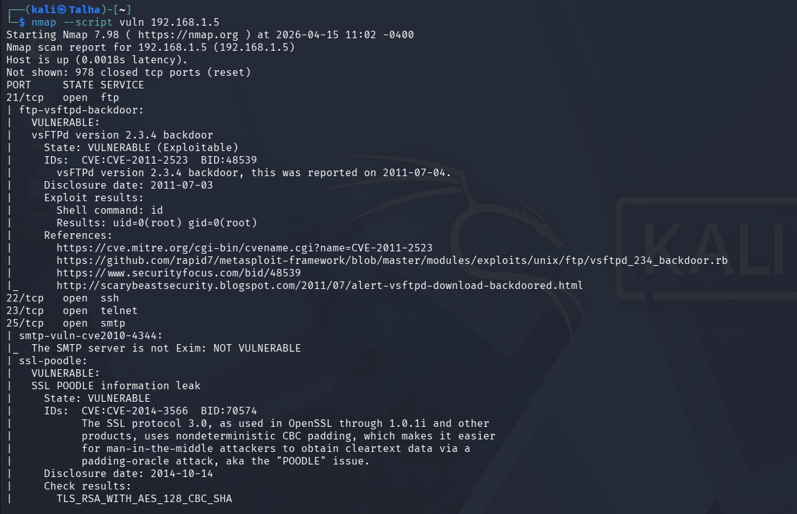
6. Active Enumeration
Commands used: nmap --script smb-enum-users 192.168.1.5
- nmap --script smb-enum-shares 192.168.1.5
- Users Found:
  - Active/Normal Accounts: msfadmin (RID: 3000), user (RID: 3002)
  - Disabled/System Accounts: Multiple built-in and service accounts were identified, including root, backup, bin, daemon, ftp, mysql, postgres, www-data, and others.
- Groups Found: (Not explicitly queried in this SMB script run, but implied via standard Linux/Samba defaults)
- Shares Found:
  - \\192.168.1.5\IPC$ - IPC Service (Anonymous access: READ/WRITE)
  - \\192.168.1.5\tmp - Type: DISKTREE, Comment: "oh noes!" (Anonymous access: READ/WRITE) - High Risk
  - \\192.168.1.5\ADMIN$ - IPC Service (Anonymous access: None)
  - \\192.168.1.5\opt - Type: DISKTREE (Anonymous access: None)
  - \\192.168.1.5\print$ - Printer Drivers (Anonymous access: None)
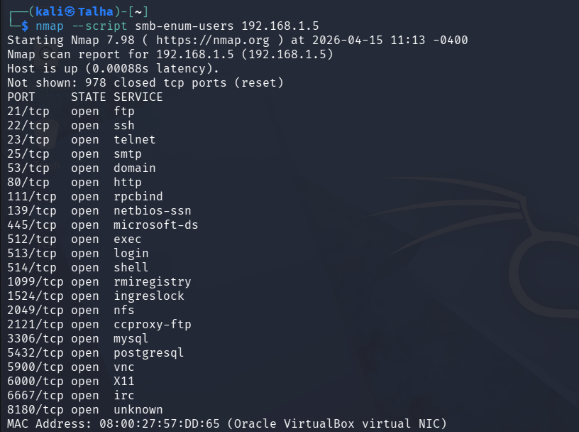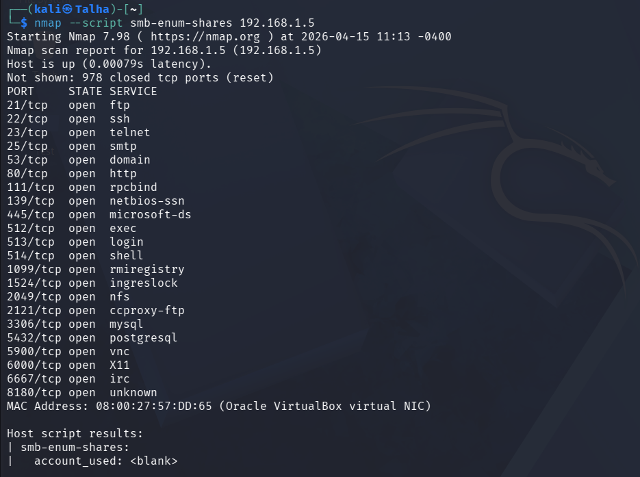
7. Conclusion
- Summary of Target: IP Address: 192.168.1.5
  - Hostname/System: Metasploitable 2 (metasploitable.localdomain)
- Final Assessment: A comprehensive network and vulnerability scan was conducted against the target IP 192.168.1.5. The host was identified as running an outdated Linux 2.6.X kernel. The system presents a massive attack surface with 28 open TCP ports exposing various outdated services, including FTP, SSH, Telnet, HTTP, SMB, databases (MySQL/PostgreSQL), and IRC.
The vulnerability assessment flagged several critical, easily exploitable weaknesses:
  - Critical Backdoors: The vsFTPd service (Port 21) and UnrealIRCd service (Port 6667) contain known backdoors that allow for immediate remote code execution and root access.
  - Web Application Flaws: The HTTP service (Port 80) hosts vulnerable applications (like Mutillidae) susceptible to multiple SQL Injections and CSRF attacks.
  - Misconfigurations: The Java RMI registry (Port 1099) allows for remote class loading, and older SSL/TLS configurations are vulnerable to POODLE and CCS Injection.
  - Exposed Enumeration Data: Active SMB enumeration successfully extracted valid user accounts (e.g., msfadmin, user) and revealed misconfigured network shares. Specifically, the \tmp and IPC$ shares allow anonymous READ/WRITE access, providing a trivial entry point for payload uploads.
Overall Risk: The target system is critically vulnerable and can be compromised through multiple distinct attack vectors.

